CS 506 Programming for Computing
PE05 Image Manipulation in Python
School of Technology & Computing (STC)
City University of Seattle (CityU)



Before You Start
- If you have questions about the programming exercise requirements, please ask a TA to clarify for you.
- If you are not sure what to do:
  - Consult the resources listed below.
  - If you cannot solve the problem after a few tries, ask a TA for help.

What and how to submit
- Write Python programs to complete the exercises below.
- Once you have solved all given exercises, submit the source code to Brightspace

Lab Tasks
- Write Python programs to complete the given tasks

Introduction: This week’s assignment involves several basic image processing techniques that enhance the overall image using PIL (ImageFilter and ImageEnhance) library. There are many filters available to modify the quality of images. For instance, when the image too dark with lower contrast, one can use equalize (https://en.wikipedia.org/wiki/Histogram_equalization) or the image is captured too blurred due to motion, one can use unsharp masking filter (https://en.wikipedia.org/wiki/Unsharp_masking#Digital_unsharp_masking).

Input Image | After histogram equalization
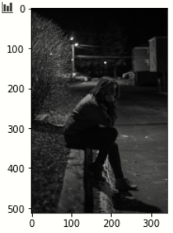 | 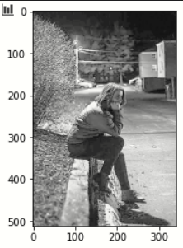
Input Image | After unsharp_mask
 | 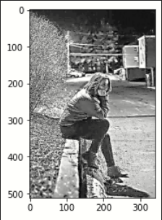

Part 1 involves reviewing the image filters and image enhancer that are available in Pillow (PIL) links.

https://pillow.readthedocs.io/en/stable/reference/ImageFilter.html

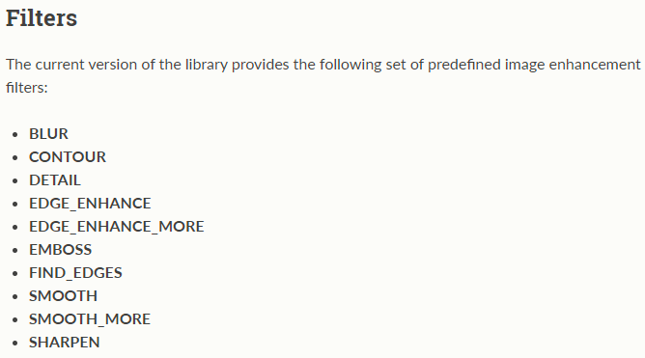

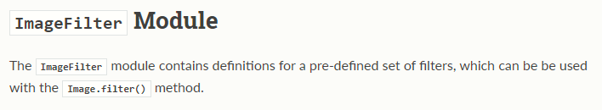

https://pillow.readthedocs.io/en/stable/reference/ImageEnhance.html

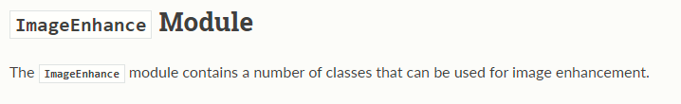

Example code snippet
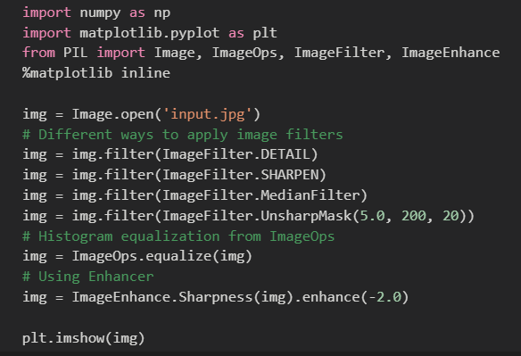

Part 2 requires you to apply necessary filters to improve the quality of the input image posted in BB to answer the following questions. Submit both your code and output image to support your answers. Make sure your answers are written in the code comment rather than in a separate document.

PE05-input.jpg
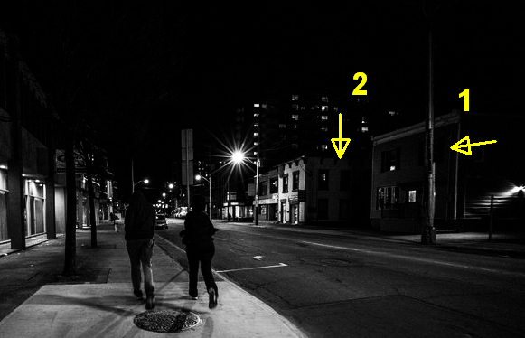

Answer the following questions after you improved the image as an output image.
- How many people do you see in the output image?
- How many trees can you identify?
- How many windows can you identify on the 2nd floor of the first building (labelled as “1”) on the right-hand side of the road?
- How many windows can you identify in the second building (labeled as “2”) on the right-hand side of the road facing you?

